* When a student lands on this form before May 06th, following message will be displayed.

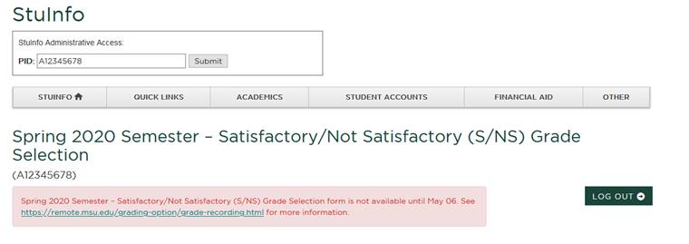

* When the student tries to use this form after May 20th, following message will be displayed.

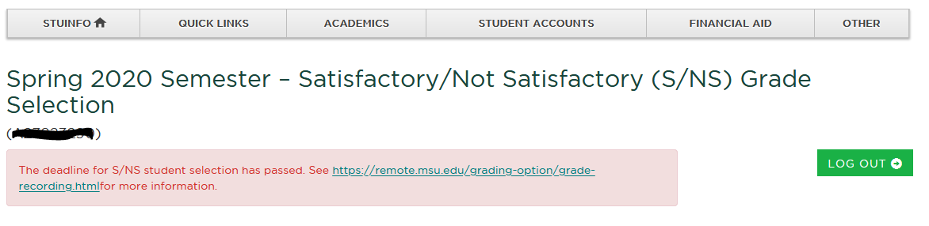

* When the logged in student is not enrolled in SS20 classes.

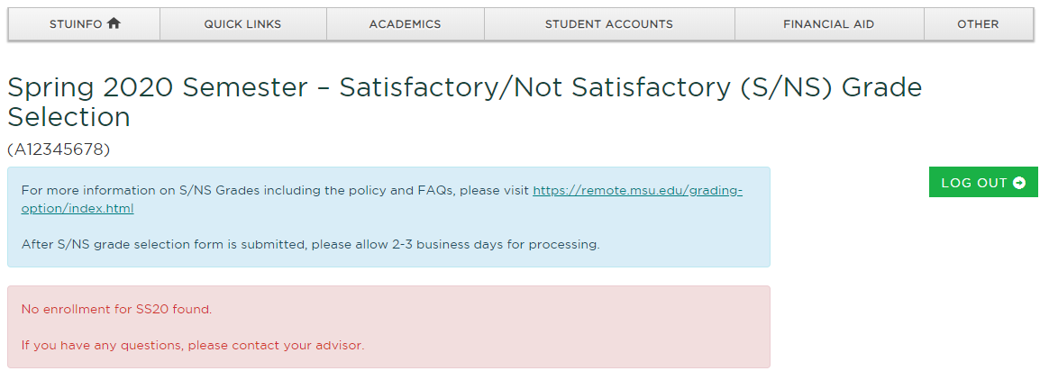

* When a student with a not eligible student level is logged in.

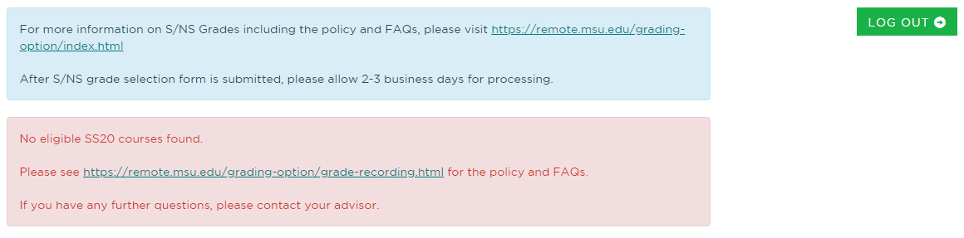

* When a course is not numerically graded.

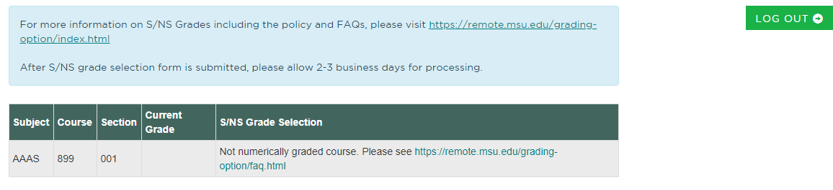

* When the courses are found but the grades are not yet submitted.

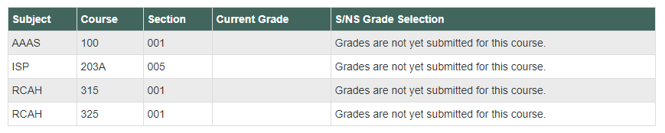

* If UN/AT/LU/EL and <1.0 or if GR, GC, LG and <2.0 then NS choice.

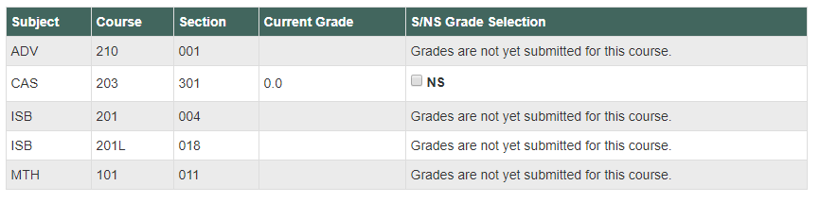

* If UN/AT/LU/EL and >=1.0 or if GR, GC, LG and >=2.0 then S choice.

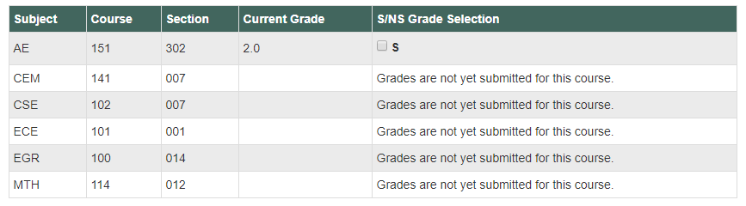

* When the grade change to NS/S is already submitted.

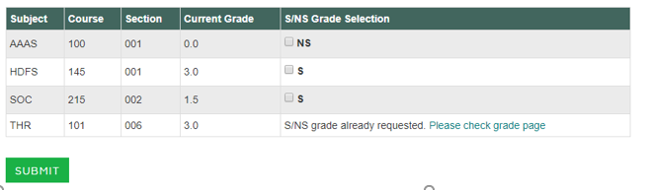

* When a student has conditional grade.

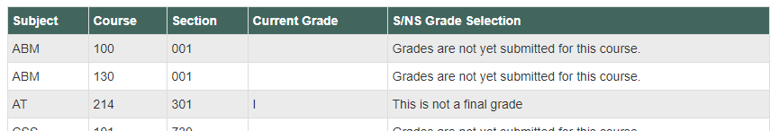

* When checkbox is selected, and the form is submitted.

